**Coaching Management Project**

**Epistêmê**

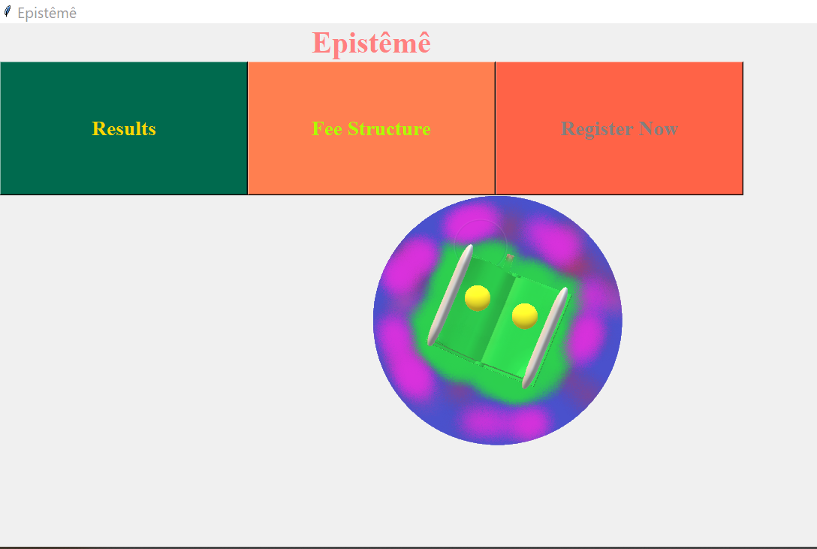

**Name of the Student:** Yagya Mohan

**Class:** XII

**Section:** A1

**Board Roll No.:**

**Certificate**

This is hereby certified that this project, **Epistêmê** entitled is the bonafide work of **Yagya Mohan** a student of class **XII A1** of **Delhi Public School, Ghaziabad, Meerut­­­­ Road**. The project has been completed under the guidance of **Mr. Mohit Saras** during the session **2021-22.**

Name of Examiner:

Signature of Examiner:

Name of the Subject Teacher:

Signature of the Subject Teacher:

**Acknowledgement**

I would like to thank the Almighty for always bestowing upon me blessings, my respected teacher, Mr. Mohit Saras, who guided and supported me throughout the course of this project and my parents and sibling, my pillars of strength. I would also like to extend my gratitude to Mr. Ankit Chauhan for his valuable inputs and support.

**Index**

|  |  |  |
| --- | --- | --- |
| **SNo.** | **Topic** | **Page No** |
| 1. | System Description at a Glance | 5 |
| 2. | Limitations of the Project | 6 |
| 3. | Problem Description | 6 |
| 4. | System Requirements | 7 |
| 5. | Bibliography | 8 |

**System Description at a Glance**

A coaching is an institution which imparts knowledge to students and trains them in order to help them compete and clear competitive examinations. The enrolment process requires each candidate to fill up his/her details like name, Adhaar no., address, class, target exams, guardian’s Adhaar no., etc. The Aadhaar no of the student is used to uniquely identify each candidate registering with the institution. In case of identical names, it is the Aadhaar No that helps to distinguish between two students. Siblings registering with the institution have the same entries of Guardian’s Adhaar No. The institute can analyse its performance in the previous years and thus, can strive towards better results.

**Limitations of the Project**

1. Difficult to run on mobile phones.
2. The program can’t be run in offices with cloud-based system.
3. Only the admin of the computer has access to the program.
4. Work which has been started on one computer can’t be continued on the other as the systems are not connected via the program.

**Problem Description**

Gone are the days when people had to stand in long queues to get themselves registered and members of the organization had to record all details and hunt for them manually. This project has been undertaken, keeping in mind the vast progress that has been made in the field of data storage and analysis. The tedious process of registration has been eased to a great extent. An internet connection, laptop, typing, and the job is done!

**System Requirements**

· Intel Processor of Speed: 500mhz

· RAM:128 MB for client and 512 MB for server.

· Windows 98/XP/2000/NT.

· MYSQL version for windows (x86) (MYSQL 4.0 or 5.0 or higher)

**Bibliography**

<https://www.youtube.com/watch?v=YR3h2CY21-U>

<https://www.c-sharpcorner.com/blogs/basics-for-displaying-image-in-tkinter-python>

<https://www.geeksforgeeks.org/how-to-create-a-pop-up-message-when-a-button-is-pressed-in-python-tkinter/>

<https://www.plus2net.com/python/tkinter-mysql.php>

<https://www.youtube.com/watch?v=AK1J8xF4fuk&t=1213s>

<https://www.plus2net.com/python/tkinter-mysql.php#:~:text=We%20will%20use%20one%20tkinter,name%20of%20your%20MySQL%20database>.

<https://www.geeksforgeeks.org/how-to-set-font-for-text-in-tkinter/>

<https://www.codegrepper.com/code-examples/python/how+to+create+multiple+windows+in+tkinter+with+button>

NCERT Book-Class 12